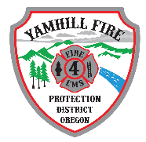

AGENDA

YAMHILL FIRE PROTECTION DISTRICT  
BOARD OF DIRECTORS MEETING  
275 South Olive, Yamhill, Oregon  
August 1 , 2024 @ 7:00pm

1. Call to Order
2. Roll Call
3. Public Hearing – (Must be open for a minimum of 5 minutes)
4. Public Comment-This time is provided for persons in the audience to speak on any item of District business, except those items which appear on this agenda; however, the district reserves the right to defer any requests for action from persons addressing the Board who have not been placed on the agenda. Comments shall be limited to three minutes, at the Board Presidents discretion.
5. Volunteer Comment: This time is provided for volunteers of Yamhill Fire Protection District to speak on any items of Volunteer or District business.
6. Old Business
   1. Strategic Plan – on hold
7. New Business
8. Announcements
9. Adjournment